**An Enterprise Resource Planning System (ERP)**

**For Pharmaceutical Company Distributor**

#### By

**Rajan Mahida (CE-063)**

**Tarang Parikh (CE-083)**

**Udit Parmar (CE-085)**

**Khushi Desai (CE-025)**

**A project submitted**

**In**

**Partial fulfillment of the requirements for the degree of**

**BACHELOR OF TECHNOLOGY**

**In Computer Engineering**

**Internal Guide External Guide**

*Prof. P. M. Jadav Mr. Ujjawal Aggrawal*

*Associate Professor Managing Director*

*Dept. of Comp. Engg. Croods Consolidates Pvt. Ltd.*



**Faculty of Technology**

**Department of Computer Engineering**

**Dharmsinh Desai University**

#### April 2017

**CERTIFICATE**

This is to certify that the project work titled

**An Enterprise Resource Planning System (ERP)**

**For Pharmaceutical Company Distributor**

Is the bonafide work of

**Rajan Mahida CE-063 ID No. 14CEUON115**

**Tarang Parikh CE-083 ID No. 14MHUOS122**

**Udit Parmar CE-085 ID No. 14CEUBS047**

**Khushi Desai CE-025 ID No. 14ECUOG037**

Carried out in the partial fulfillment of the degree of Bachelor of Technology in Computer Engineering at Dharmsinh Desai University in the academic session

**December 2016 to April 2017.**

*Prof. P. M. Jadav Dr. C. K. Bhensdadia*

*Associate Professor Professor and Head of Department*

*Dept. of Comp. Engg. Dept. of Comp. Engg.*



**Faculty of Technology**

**Department of Computer Engineering**

**Dharmsinh Desai University**

#### April 2017

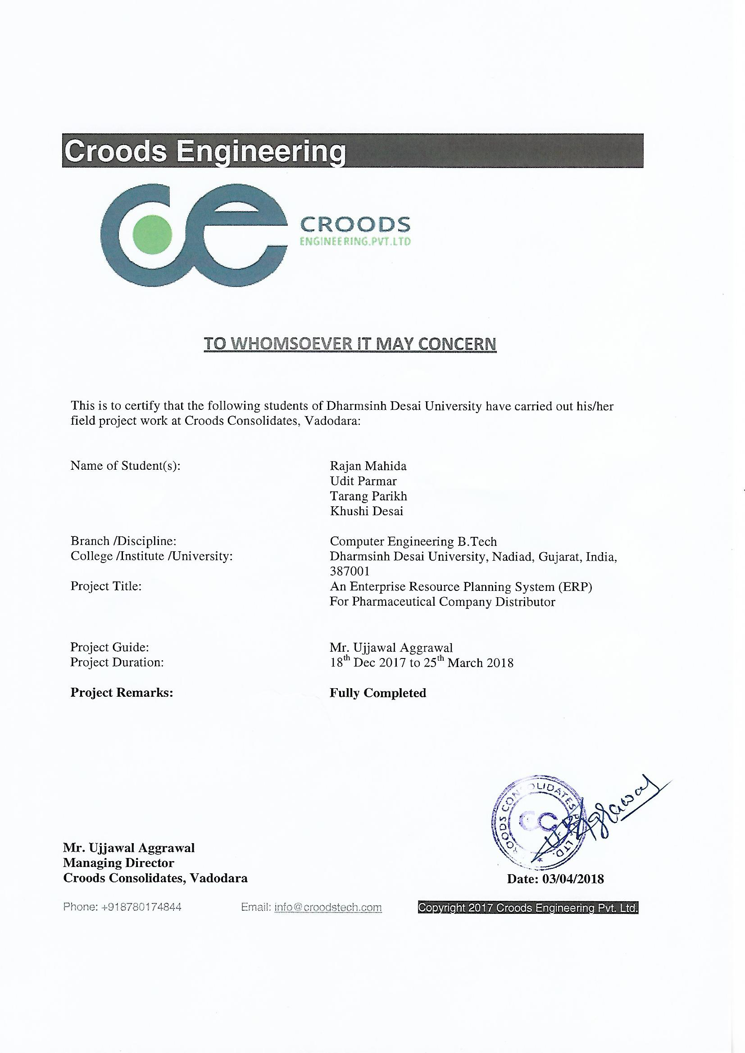

Acknowledgements

This project work appears in its current form due to the assistance, guidance and support of several people. It is our pleasure to offer sincere thanks to all of them.

We apologize in advance for any omissions. Some code and information has been omitted due to Non-Disclosure Agreement with the Company.

We feel honored to express our sincere gratitude to our Head of Computer Department Dr. C.K. Bhensdadia for providing us an opportunity to work as Interns at Croods Consolidates Pvt. Ltd., Vadodara for our final semester training.

We take immense pleasure in thanking Prof. P. M. Jadav of Computer Department at Dharmsinh Desai University, and our Managing Director Mr. Ujjawal Aggrawal with Project assistance of Mr. Bhavin Pandya at Croods Consolidates Pvt. Ltd. for helping us in any way possible to carry out this project work.

Index

**1. Introduction.........................................................................................................1**

**1.1 Purpose..................................................................................................2**

**1.2 Intended Audience and Reading Suggestions....................................2**

**1.3 Product Scope.......................................................................................2**

**1.4 Product Advantages.............................................................................3**

**2. About the System................................................................................................5**

**2.1 Overall Description..............................................................................6**

**2.1.1 Product Perspective.................................................................6**

**2.1.2 Product Functions....................................................................6**

**2.1.3 User Classes and Characteristics...........................................8**

**2.1.4 Operating Environment..........................................................9**

**2.1.5 Design and Implementation Constraints...............................9**

**2.1.6 User Documentation...............................................................10**

**2.1.7 Assumptions and Dependencies............................................10**

**2.2 External Interface Requirements......................................................11**

**2.2.1 User Interfaces........................................................................11**

**2.2.2 Hardware Interfaces..............................................................11**

**2.2.3 Software Interfaces................................................................11**

**2.2.4 Communications Interfaces...................................................19**

**2.3 System Features..................................................................................20**

**2.3.1 Registration and Login..........................................................20**

**2.3.2 Place Order to Supplier.........................................................21**

**2.3.3 Pass Client Order...................................................................23**

**2.3.4 Messaging and Task Reminders...........................................24**

**2.3.5 Generate Invoice/ Record and Reports................................25**

**2.3.6 Make Outstanding Payments................................................26**

**2.3.7 View Statistics.........................................................................26**

**2.4 Other Non-Functional Requirements................................................28**

**2.4.1 Performance Requirements...................................................28**

**2.4.2 Safety Requirements..............................................................28**

**2.4.3 Security Requirements...........................................................28**

**2.4.4 Software Quality Attributes..................................................29**

**3. Analysis..............................................................................................................31**

**3.1 Use-Case Diagram...............................................................................32**

**3.2 ER Diagram.........................................................................................33**

**3.3 Class Diagram.....................................................................................34**

**3.4 Sequence Diagram..............................................................................35**

**3.5 Activity Diagram................................................................................38**

**4. Design.................................................................................................................39**

**4.1 Database Schema................................................................................50**

**4.2 Code Navigation.................................................................................54**

**5. Module Description...........................................................................................68**

**5.1 Employee Module...............................................................................69**

**5.2 Client Module.....................................................................................70**

**5.3 Outlet Module.....................................................................................70**

**5.4 Finance Module..................................................................................71**

**5.5 Supplier Module.................................................................................72**

**6. Implementation.................................................................................................74**

**7. Test Case Design...............................................................................................80**

**7.1 Testing Plan........................................................................................81**

**7.2 Testing Strategy..................................................................................81**

**7.3 Testing Method...................................................................................82**

**7.4 Test Cases............................................................................................82**

**8. Conclusion and Future Enhancements...........................................................88**

**9. Appendix............................................................................................................90**

**10. Bibliography..................................................................................................102**

Tables

**2.1 Software Technologies Used............................................................................5**

**4.1 Data Dictionary.................................................................................................5**

**7.1 Rest API Testing...............................................................................................5**

**7.2 Data Access Object Testing (DAO) ................................................................5**

**7.3 Controller Testing.............................................................................................5**

**7.4 View Testing......................................................................................................5**

Images

**2.1 Chocolatey Package Manager..........................................................................5**

**2.2 Build System on Command Prompt................................................................5**

**2.3 Apache Tomcat..................................................................................................5**

**2.4 Apache Maven...................................................................................................5**

**2.5 Maven Repository.............................................................................................5**

**2.6 Jersey Core Client.............................................................................................5**

**2.7 Jersey Media Multipart...................................................................................5**

**2.8 JSoup Java HTML Parser...............................................................................5**

**2.9 Guava Library for Java...................................................................................5**

**2.10 Oracle Glassfish Server..................................................................................5**

**2.11 SDK Manager..................................................................................................5**

**6.1 Supplier Interface.............................................................................................5**

**6.2 Document Reporting & Handling...................................................................5**

**6.3 Creating Documents & Reports......................................................................5**

**6.4 Document and Report Display with Notifications.........................................5**

**6.5 Messaging Interface..........................................................................................5**

**6.6 Composing Messages with Attachment Feature............................................5**

**6.7 Messaging - Inbox.............................................................................................5**

**6.8 Reading Messages.............................................................................................5**

**6.9 Drugs and Medicine..........................................................................................5**

**6.10 Registration.......................................................................................................5**